**Work Limitation**

***Work-flow to Use Work Limitation***

Use **Add Preference** to obtain a baseline dialog that sets Work Limitations



Repeat **Add Preference** for additional instances of the baseline dialog



***Preference Overview***

This preference collects together all of the main driver work limitations - working time and breaks. They are frequently governed by regulatory limits and by union agreements. Applying tight constraints to working time and breaks is not practicable. A simple example is a driver with a work time limitation of 12 hours completing his shift in 13 hours due to traffic delays. To meet these kind of situations, you can add a flexibilty limit of say 3 hours to the "constraint" value of 12 hours allowing a duty shift of up to 15

hours, with a penalty for overrunning 12 hours. The example is developed in more detail below.

***Add Preference Dialog***

**Prerequisites:** None.

**Opening Dialog:**

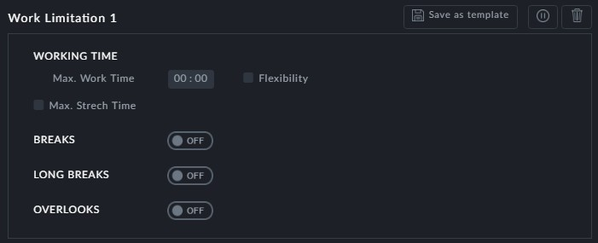

*Figure 1-1: Work Limitations dialog*

Many of the fields in this dialog open sub-dialogs. We will look at each of the four groups in **Figure 1-1** in detail.

***WORKING TIME***

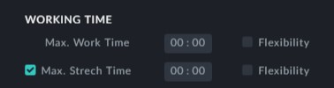

This group opens up as follows if we check the **Max. Stretch Time** and **Flexibility** boxes:

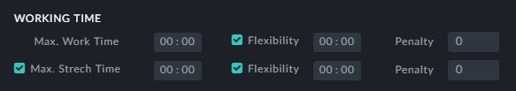

**Max. Work Time** is the maximum duty shift time net of splits break time. For example you can set this to 12 hours as a constraint. It might be more practical to allow it to increase to 15 hours with a penalty for overrun. To do this, set the **Flexibility** time to 3 hours and the **Penalty** , say to 20. The actual penalty incurred will start at zero for no overrun to a maximum of 20 for a 3 hour overrun.

**Max. Stretch Time** is the maximum duty shift time including split break times. The flex- ibility and penalty considerations work in the same way as for **Max. Work Time**.



It is your responsibility to ensure the consistency of the times that you

enter here. For example, **Max. Stretch Time** cannot be less than **Max. Work Time**.

***BREAKS***

Switching on **BREAKS** opens the following dialog:

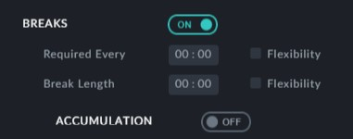

Checking **Flexibility** opens it further:

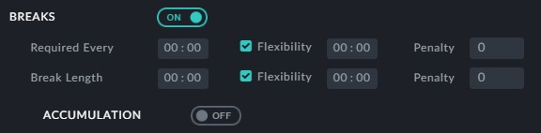

**Required Every**: Typically, breaks are required after a maximum actual driving time. For

example, a break of 30 min. might be required after 4 hours of continuous driving. Again it may not be realistic to set these two values as constraints. In our example, it may be more practical to allow an overrun of 2 hours by setting a **Flexibility** level of 2 hours with a penalty of say 20. The penalty is proportional, starting at zero for no overrun to 20 for

2 hours.

**Break Length** flexibility works in the opposite direction. For a break of 30 min. we

might set the Flexibility value to 15 min. and the penalty will increase as we decrease the break time. Remember that the penalty here is based on an **hourly** violation, not per minute.

**BREAKS**ð**ACCUMULATION**

During the course of a full shift, there may be many small breaks. Accumulation enables you to aggregate these small breaks to meet the overall breaks requirements.

Switching it on offers a further sub-dialog:

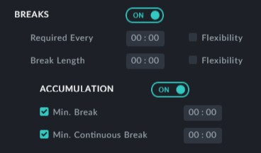

**Min. Break** is the minimum break time to be included in an accumulation. For example, we may wish to exclude minor breaks of under say, five minutes.

**Min. Continuous Break**: Here we require at least one break of this much time. If we don't have at least one such break, then nothing is accumulated.

You may check any combination of the **Min. Break** and **Min. Continuous Break** fields.

**LONG BREAKS**

Switching it on offers the next sub-dialog:

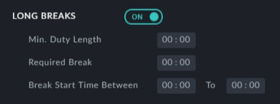

**Min. Duty Length**: LONG BREAKS are defined for duties over this minimum length.

**Required Break** is the break time.

**Break Start Time Between**: This item sets a period within the duty for which a long break may apply. It prevents long breaks from being scheduled too close to the begin- ning of a duty or too close to the end of a duty. For example in a 15 hour duty, we might require a long break of 2 hours but only after 4 hours in to the shift and commencing no later than 9 hours ii to the shift. So these fields would be set to 4:00 and 9:00 respect- ively.

**OVERLOOKS**

This is a set of six exceptions that may be switched on or off. Switching them on includes them in break time; switching them off excludes them.

|  |  |
| --- | --- |
| **Switch On** | **Include this in breaks:** |
| Signing | Sign-on/sign-off time - this is separate from  Pre/Post trip time |
| Taxi | Taxi time |
| Pre/Post  Trips | Pre/Post trip times. See **Pre Post Trip**. |
| Changeover | Vehicle changeover time |
| Boarding  Time | Boarding time. See **Boarding Time Relax- ation.** |
| Continuous  Attendance | Yes or no, not necessarily a time. See  **Continuous Attendance.** |

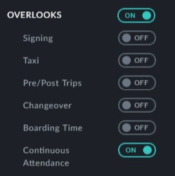

**Points to note:**

You may create additional instances of this preference for different maximum work times. There are however, no Edit Filters.



There are currently no additional Optibus templates available. Work Limitation tem-



plates have to be taylored to local regulations and Union agreements.